Stratigraphy Extra Credit
Created by Megan LeBlanc, University of Florida

Stratigraphy is the study of strata, or the layers of sediment, soil, cultural material etc., that have been deposited over time. This concept was borrowed from geology as a way for archaeologists to identify spatial and temporal relationships at their site. The law of superposition (or the basic law of stratigraphy) states that lower strata (layers) are older than upper strata. As an archaeologist, distinguishing stratigraphy is essential for understanding the relative dates of artifacts found at your site. It can also be helpful for studying changes to past environments. Once an archaeologist is finished excavating their unit, they will draw the profile of their unit to record changes to stratigraphy.

Below are pictures of pages from a Munsell Soil Color Chart. A Munsell color chart is a tool for evaluating the type of soil found at a site. When mapping stratigraphy, the soil color swatches help to visually and scientifically differentiate between color changes in stratigraphic layers. There are three main attributes to consider when reading the chart.

The first is hue, or the color. Examples of hues found on the chart include red (R), yellow-red (YR), and yellow (Y).

Next is value, which designates how light or dark a color is. On a Munsell chart, color moves vertically from light to dark (lower numbers being darker than higher numbers).

Finally, chroma, or the strength of the color, transitions from weak to strong horizontally (weak on the left to strong on the right).

If you were to identify a soil as 7.5 YR 8/6, then you would have a yellow red soil that is light in value but strong in chroma (see the star below).

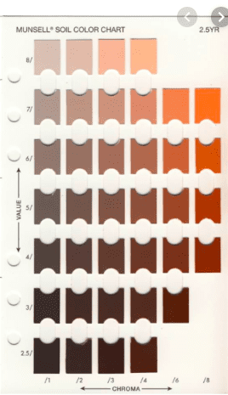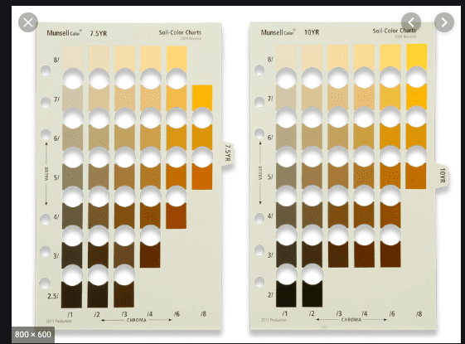
For this assignment, I have attached several pictures of stratigraphy from my dissertation site, Tacahuay Tambo, on the far southern coast of Peru. This area of Peru is right on the edge of the Atacama Desert, one of the driest deserts in the world! However, when El Niño events, a climatic event due to shifts in trade winds that warms the normally cold waters of the Pacific and causes rainfall along the desert coast. El Niño flooding can be particularly devastating when paired with this tectonically active coast causing debris flows that can wipe out human settlements.

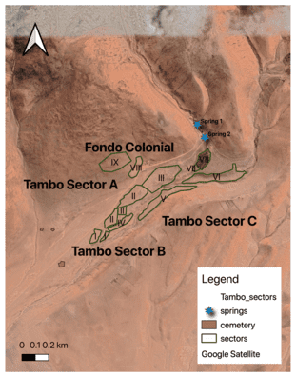
Figure 1: Location of Tacahuay Tambo. Figure 2: A map of sectors at Tacahuay Tambo as identified by Dr. Sofía Chacaltana Cortez)

The photos below are from the quebrada, or drainage, at Tacahuay Tambo. This drainage has experienced many major debris flow events that have impacted human occupations at the site. Take a look at the profiles from Tacahuay’s quebrada. What do you see? Different colors? Different types of sediments and soils? (5 points)
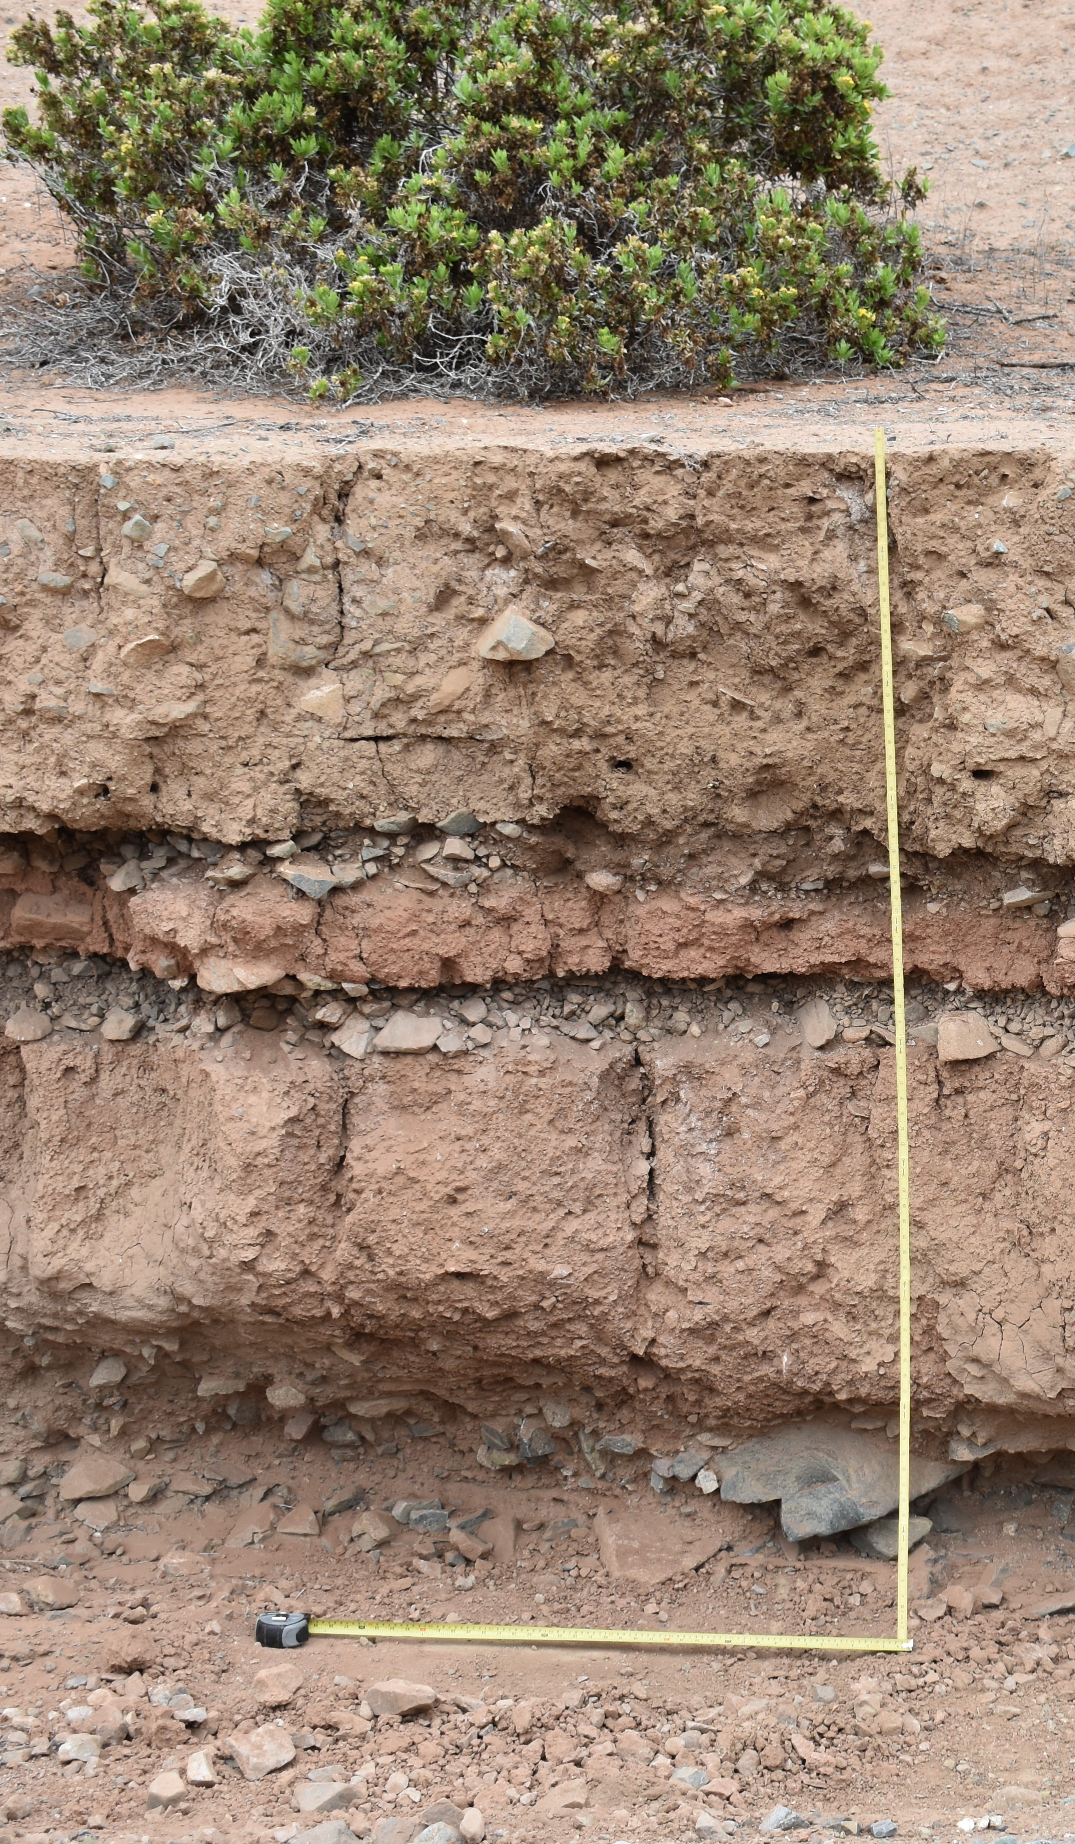
- For the first profile photograph, I want you to use the Munsell color swatches above to identify the colors you see in each stratigraphic layer (strata I, II, IV, V, and VI).

Answer Here:

I: Yellow strong in value

II: yellow red strong in chroma

IV: Red

V: Yellow

VI: red weak in

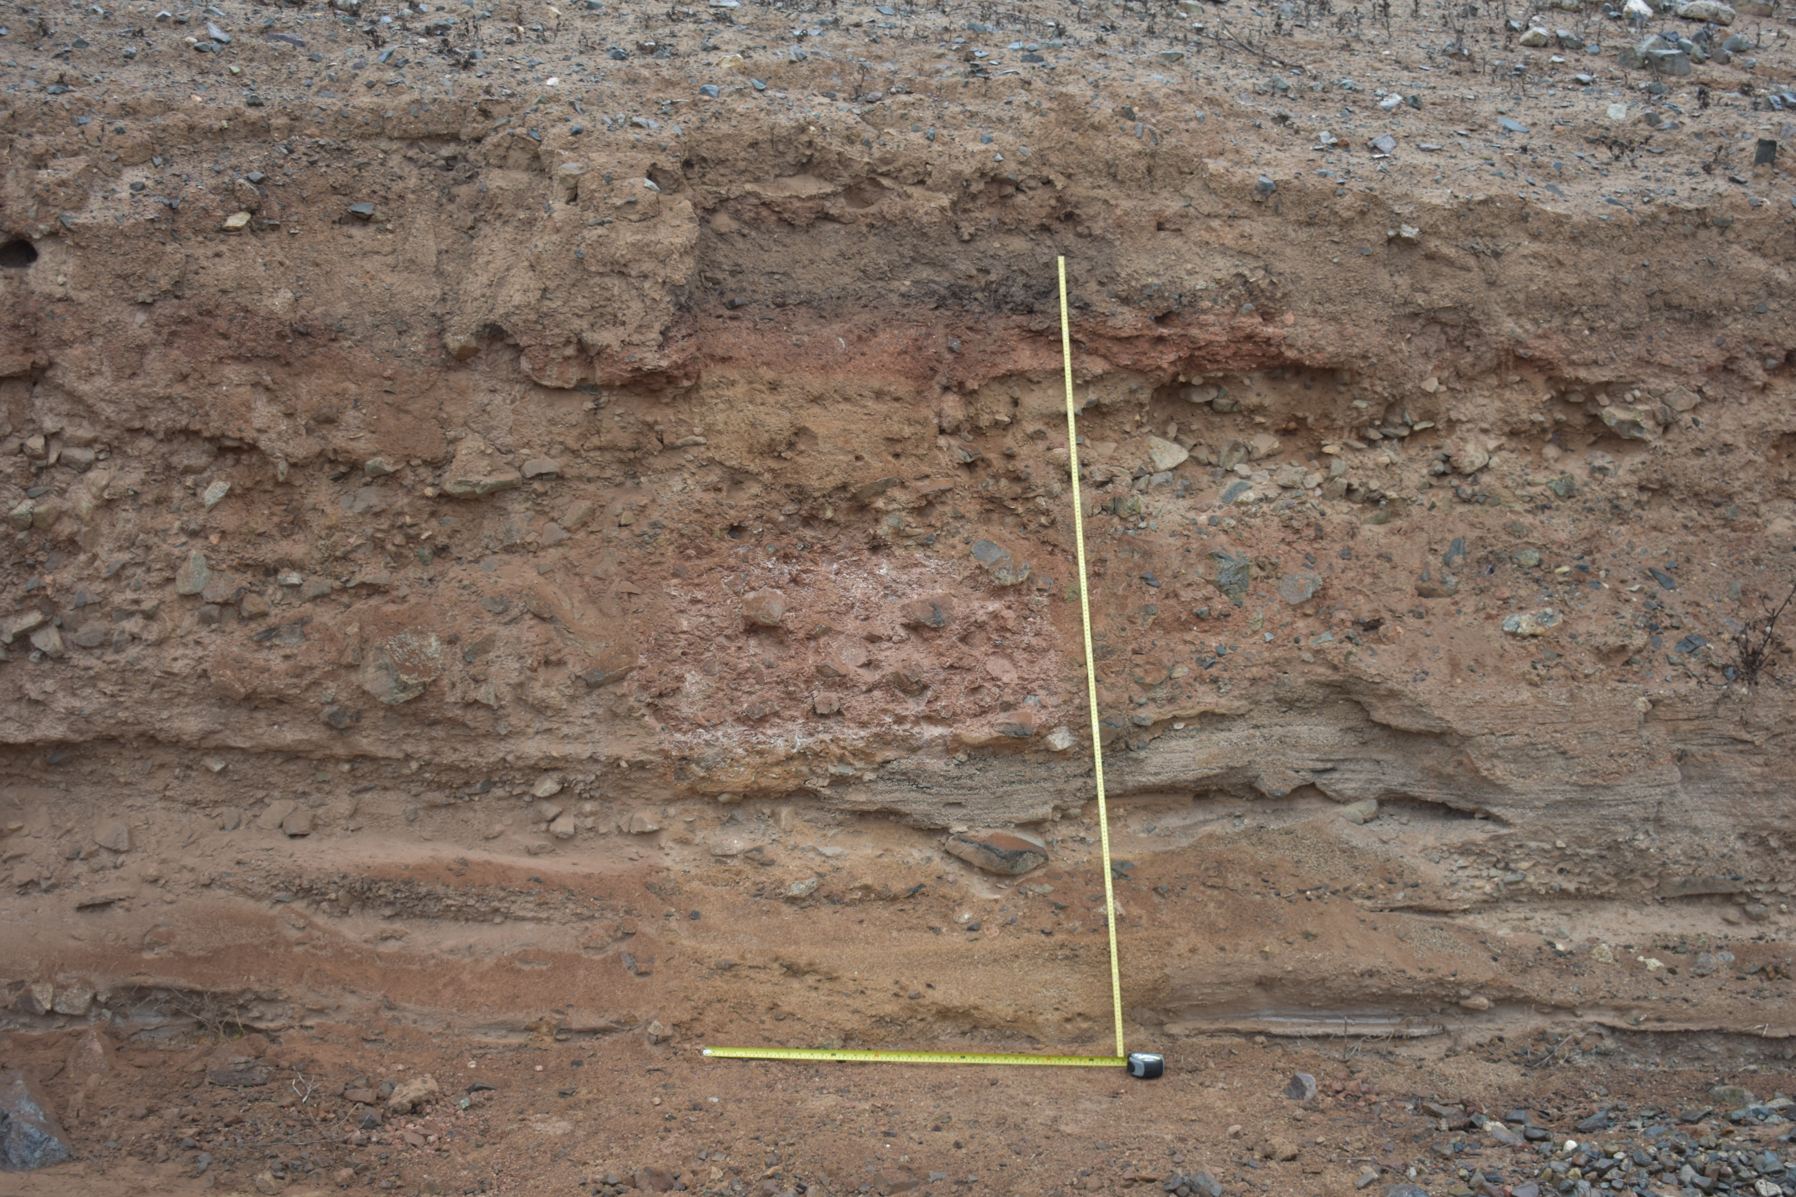
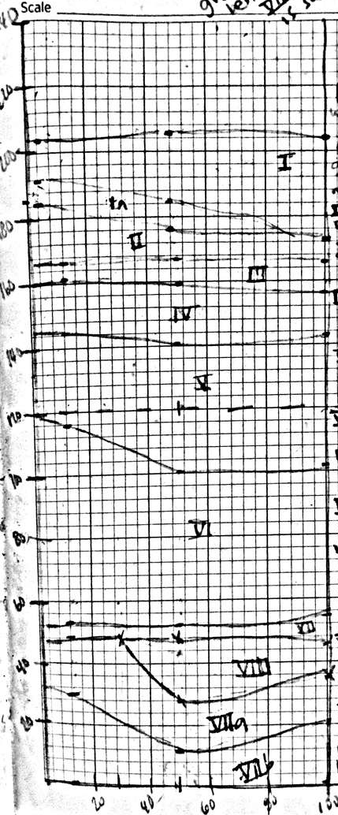
I
Ia
II
III
IV
V
VI
VII
VIII
VIIa

Profile 1: Drawing of profile 1 and photo of profile 1 with stratigraphy labeled.

- For the second profile photograph, I want you to practice drawing distinguishing between strata. Draw lines, like seen in the above example where you see changes to color or types of sediment. When looking at changes to sediment, look for changes in grain sizes. Can you see chunky rocks mixed in with dirt or does it look smooth? Are there more rocks in some layers than others? (3 points)

Profile 2
VII
VI
V
IV
III
II
I

After you draw lines on the profile, write a quick paragraph justifying where you drew your lines. (2 points)
Layers 1-3 have light value. Layer 2 has some degree of strong chroma. These are new formed layers as compared with layers 4-5 which have strong chroma which appears to be old in age.

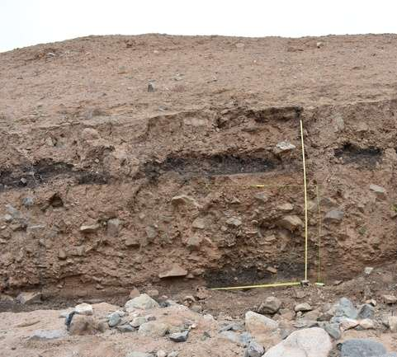

- Yellow

- Red strong chroma

- Yellow- red

- Red

- Red strong chroma

